Pump’s flow-rate modeling

From the Pin data (pressure inside the sensorbox), the pump’s flow-rate can be modeled. This process is being theoretically analyzed in the chapter 4.1.2 “Calculating pump’s flow-rate”. In the next chapters this method will be implemented on the real data gathered during the flight.

# Simplifications

For a first order analysis, some simplifications are important. The formula derived from the theoretical analysis is:

Since the duration of the pressurization, which is stage 1, is maximum 2 minutes, Tout and Pout will be considered constant values. The quantity Vin is always constant and according to the data, Tin is also a constant with significant accuracy. Therefore, the flow-rate can be expressed as:

The constant am will vary with the different cycles of the experiment. So in the cycle m, am will be expressed as:

The units will be: Vin [lit], T [K], P [mbar].

Thus, for every cycle, am and Pin derivative have to be calculated. There is no interest in calculating am so the analysis will be focused on the derivative of Pin.

One last important simplification is that the leakage is not taken into account.

# Sensorbox pressure profile

During stage 1, the air is pressurized in the sensorbox and thus the rate of change of Pin is very important for modeling the pump’s behavior.

Among different functions, the one describing the data more efficiently is:

The number of cycles that has been selected to focus on is thirty-two. For the first 20 minutes of the flight the pump was capable of providing almost constant flow-rate, or equivalently the pressure was linear, since the duration of each cycle was such that the function Pin could be approximated as linear. Also, for the last cycles of the ascending phase the pressure sensor was not reliable enough. Thus, the sample cycles selected for the pump modeling are between the first 20 and 100 minutes of the flight.

The altitude and the ambient pressure at the beginning of the corresponding cycle are described as initial conditions. The initial conditions of the sample cycles are between 5 – 27 km and 450 – ~1 mbar.

The following graph shows the pressure changing with each cycle’s duration, regarding the pressurization stage only.

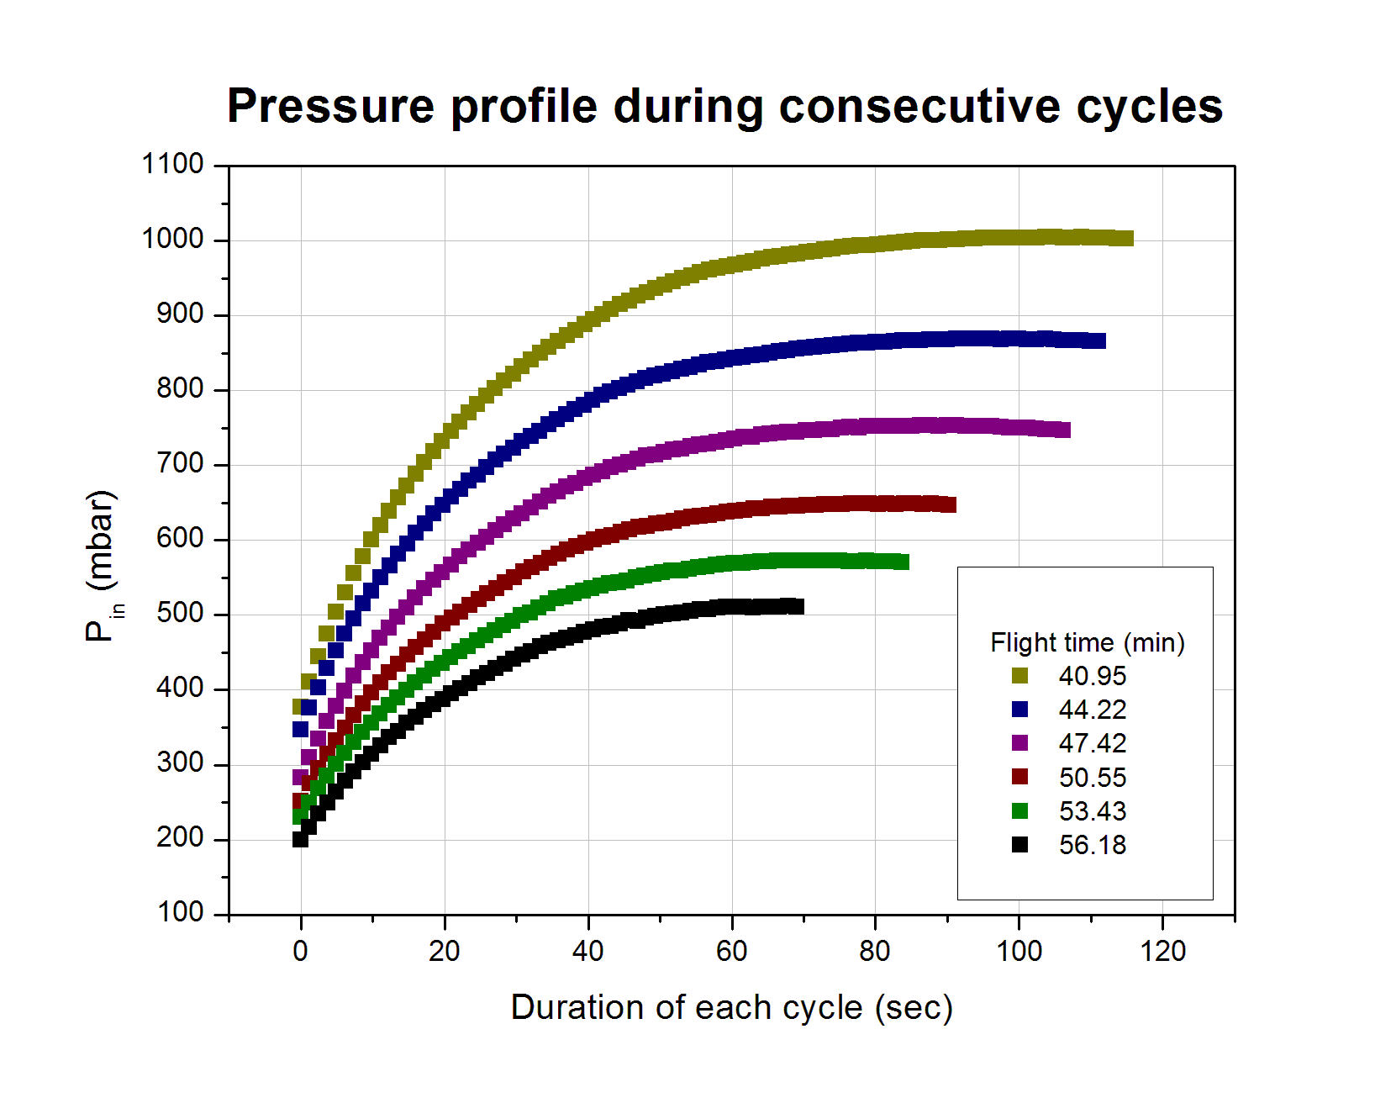

Graph 1: Pressure profile during stage 1 for different cycles

The following graphs are presenting the regression fittings for three of the sample cycles, using the aforementioned function, with the flight time of the initial conditions written in the title. The x axis shows the duration of each cycle in seconds.

Graph 2: Pin modeling during stage 1 with different initial conditions

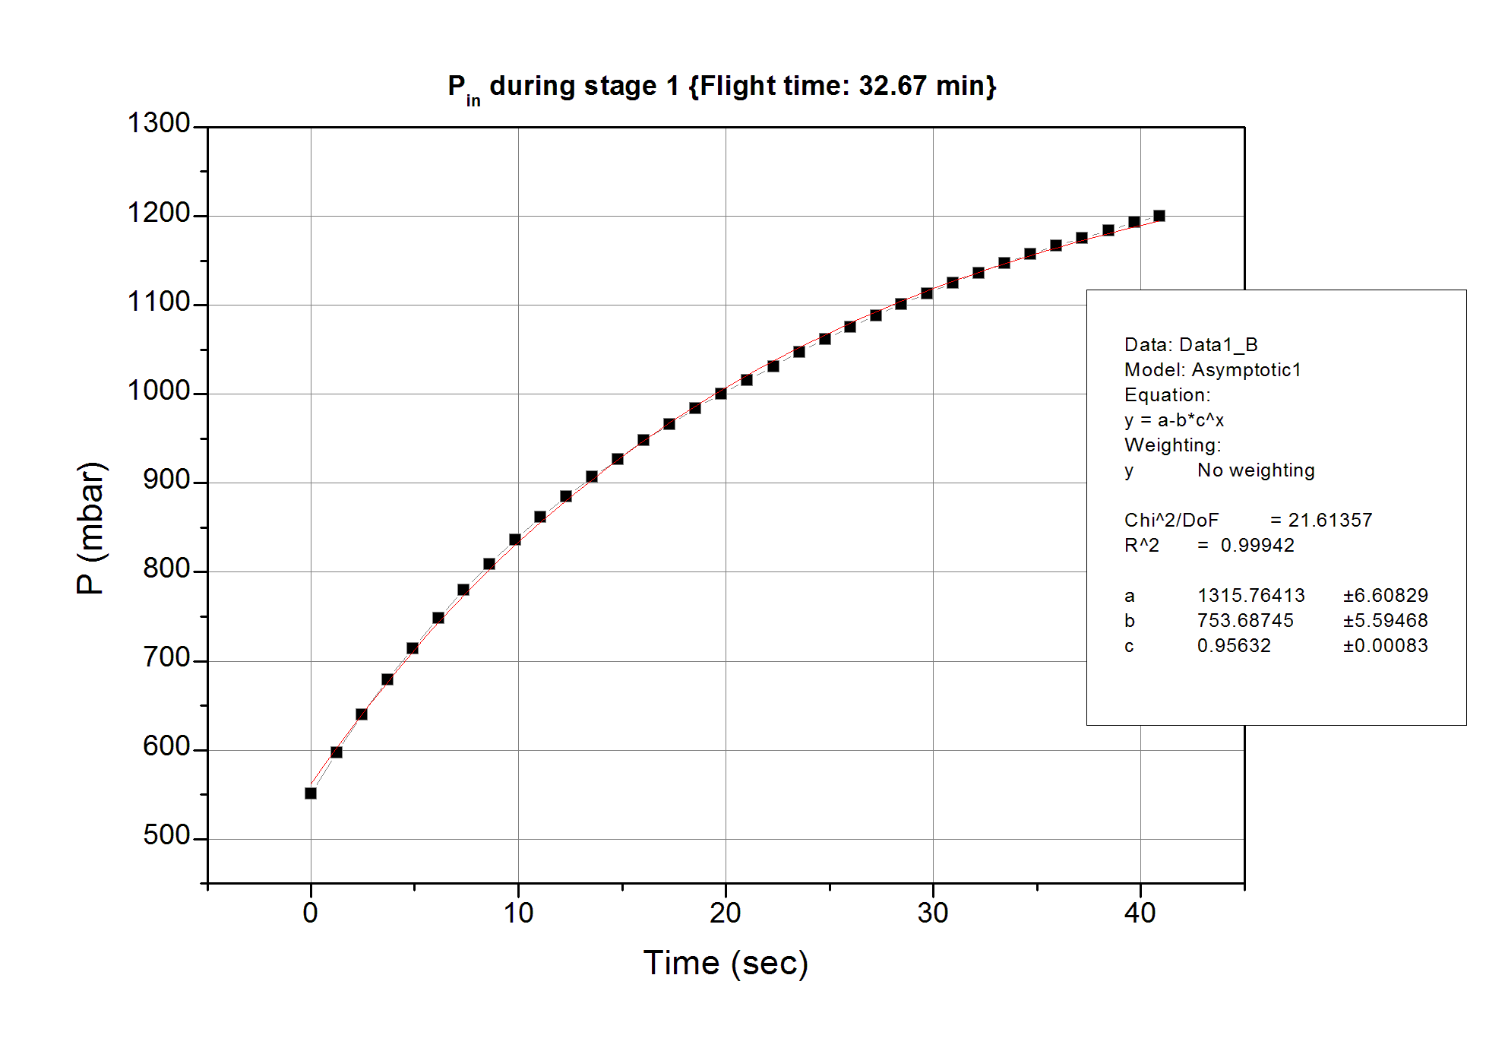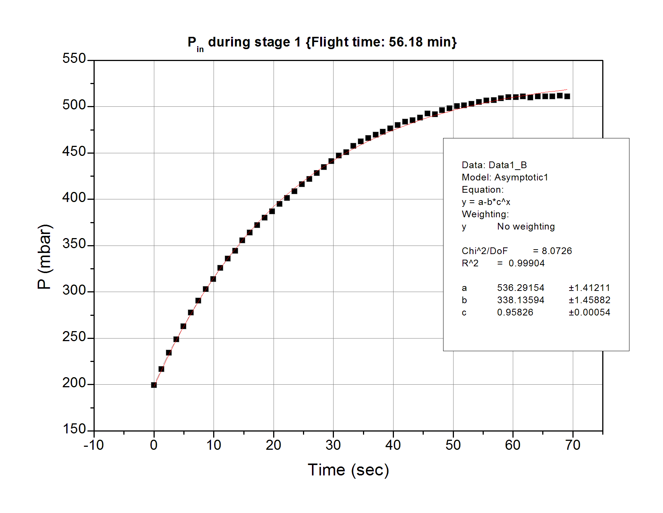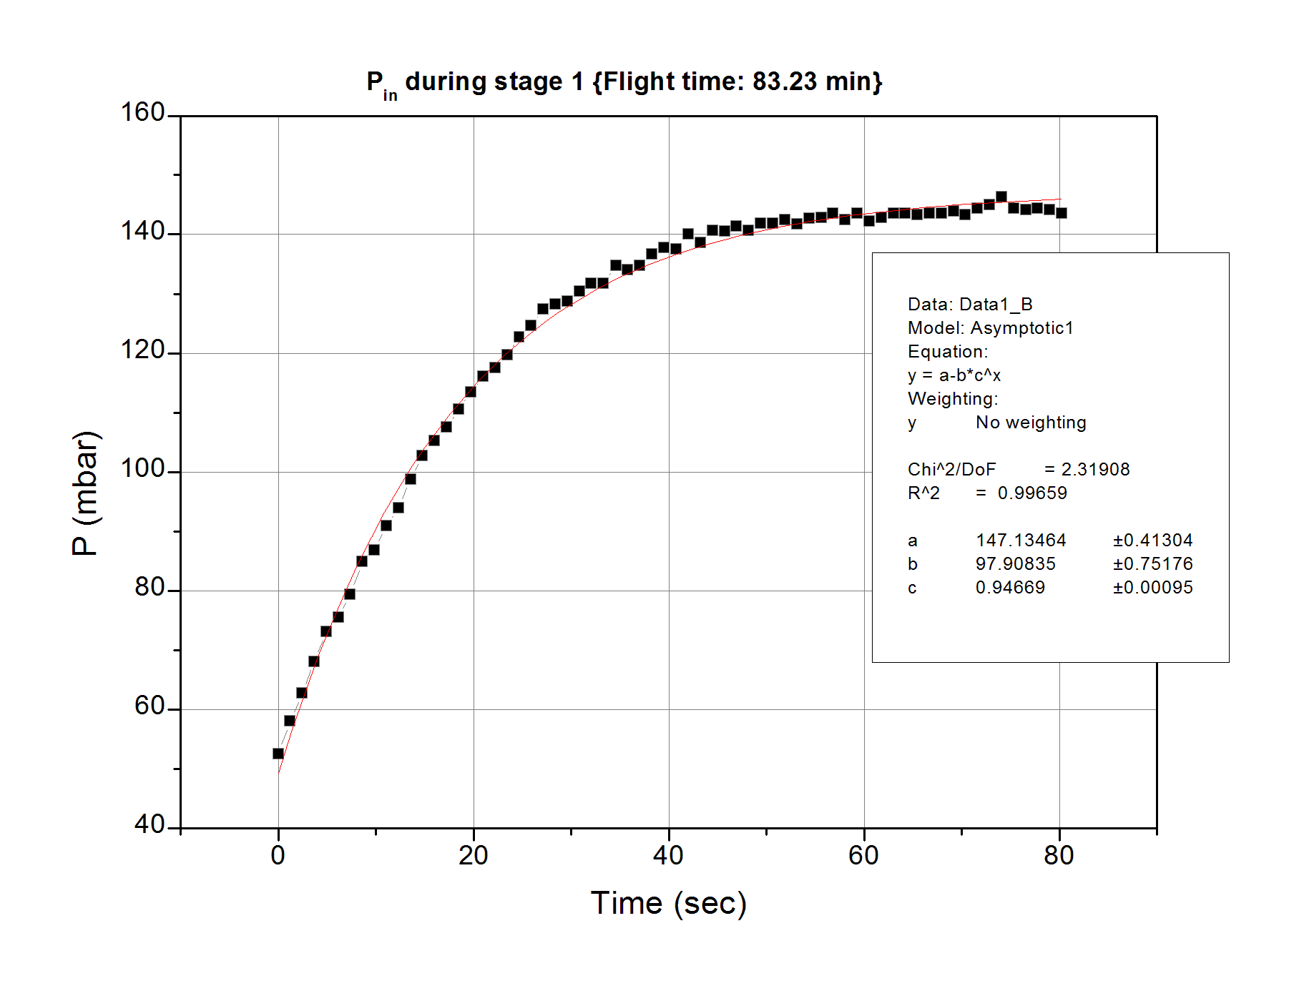

The parameters a, b and c for all the sample cycles are presented in the following table.

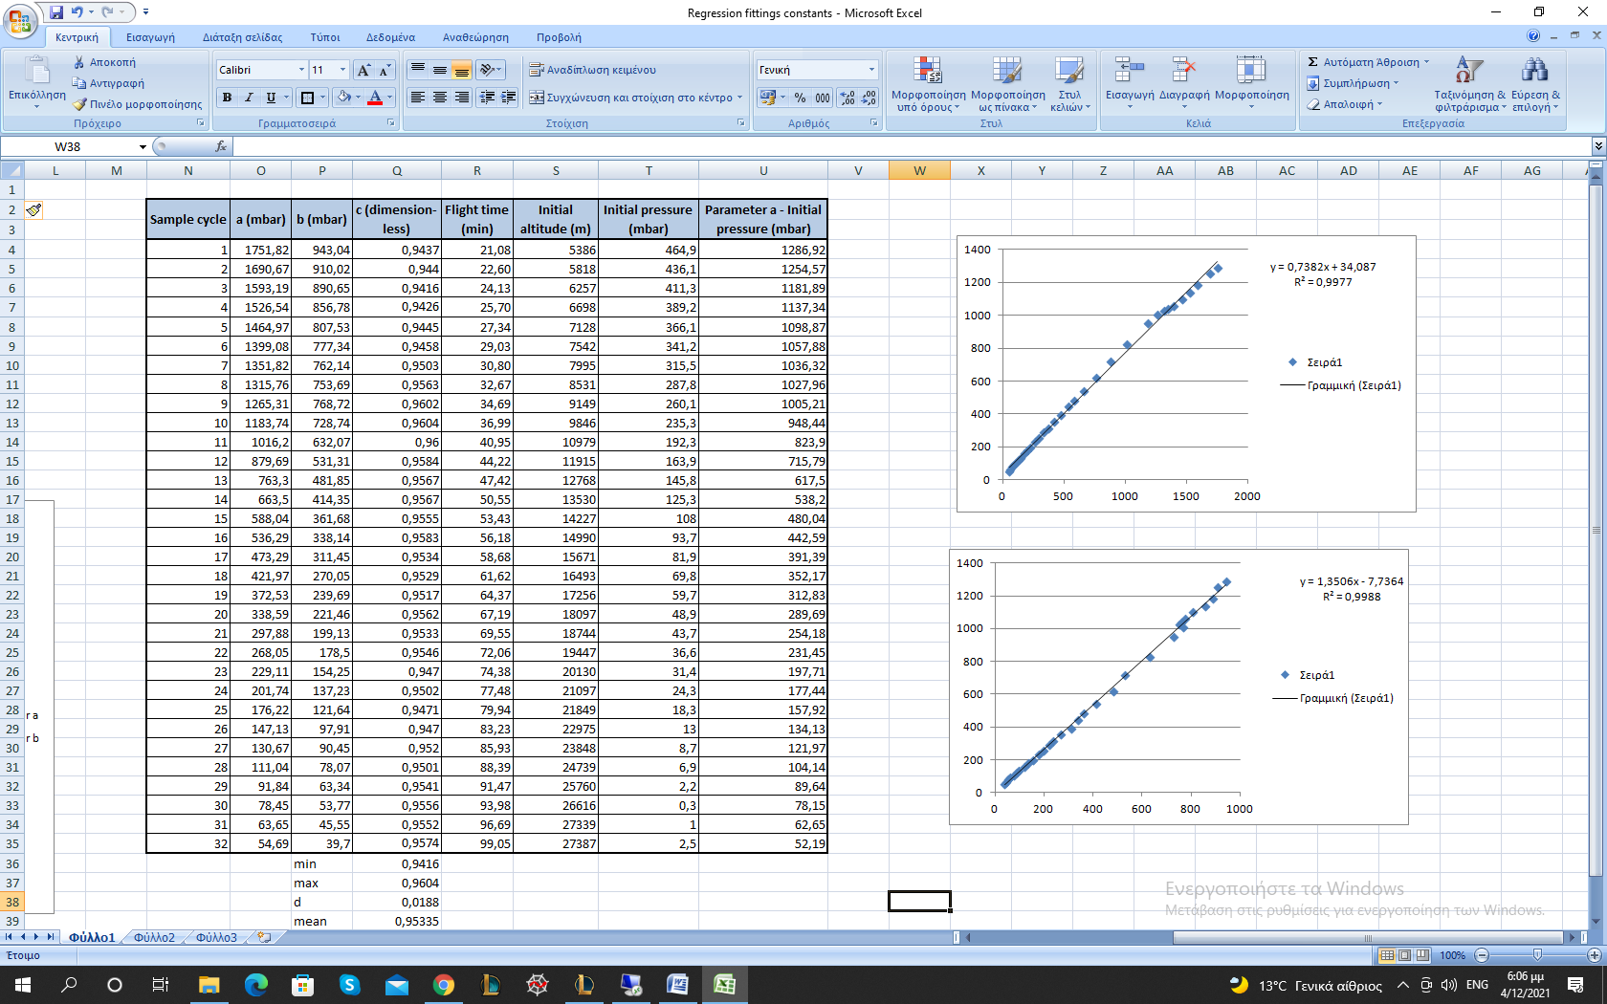

Table 1: Table of parameters and important quantities

In the first columns there are: the number of the sample cycle, the parameters a, b and c and the flight time. In the last columns there are: the initial conditions and the parameter a subtracted by the corresponding initial pressure.

There are some significant results that can be derived by examining this table. First of all, the parameter c is almost constant throughout the different cycles. The mean value of c, which is dimensionless, is:

while the maximum and the minimum c values are:

Thus, the maximum deviation from the mean value is 1.23% and hence it is acceptable to take c as constant, equal to the mean value of c.

The fact that this parameter remains constant is implying that there is no dependence on neither the initial parameters, nor the pressure difference (ΔP = P initial ambient – Pin). Thus, this quantity is characterizing the pump’s behavior. The pump will start pressurizing the air into the sensorbox, but after a relatively long time the pressure inside will tend asymptotically to the value of parameter a, since:

The other two parameters, a and b, are constantly increasing with the initial ambient temperature.

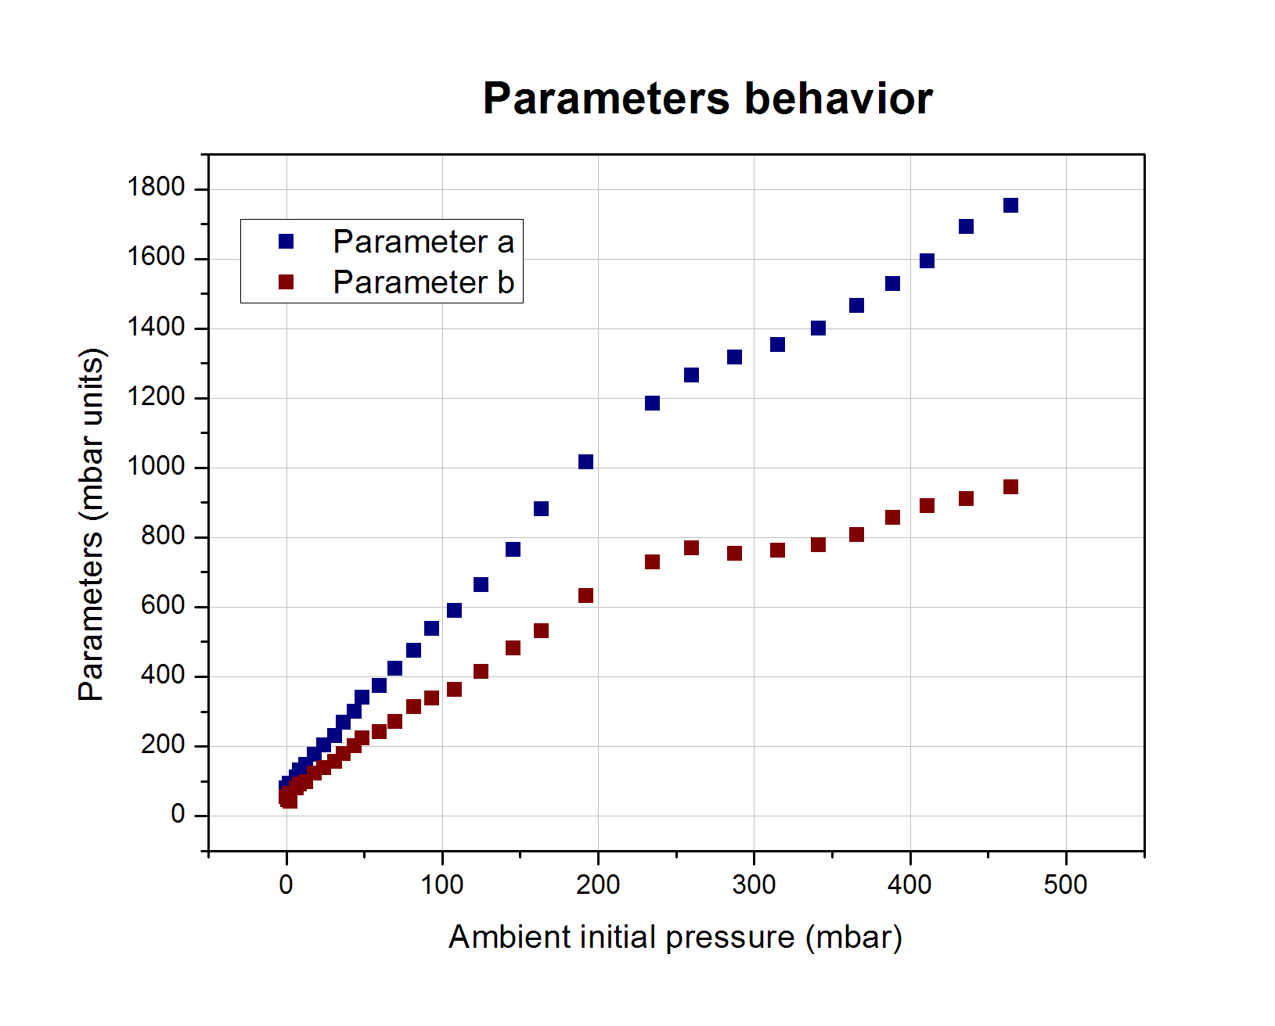

Graph 3: Parameters a and b

These two parameters are not dimensionless, but their units are millibars [mbar]. From their behavior it is clear that they strongly depend on the initial parameters, and especially on the ambient pressure. Yet, there is not an explicit relation between them.

By the form of the regression function, it is clear that the parameter a shows the maximum pressure that can be reached for a specific ambient pressure value. By subtracting the ambient pressure from the value of a, the pressure difference ΔP described above is formed, for the maximum Pin.

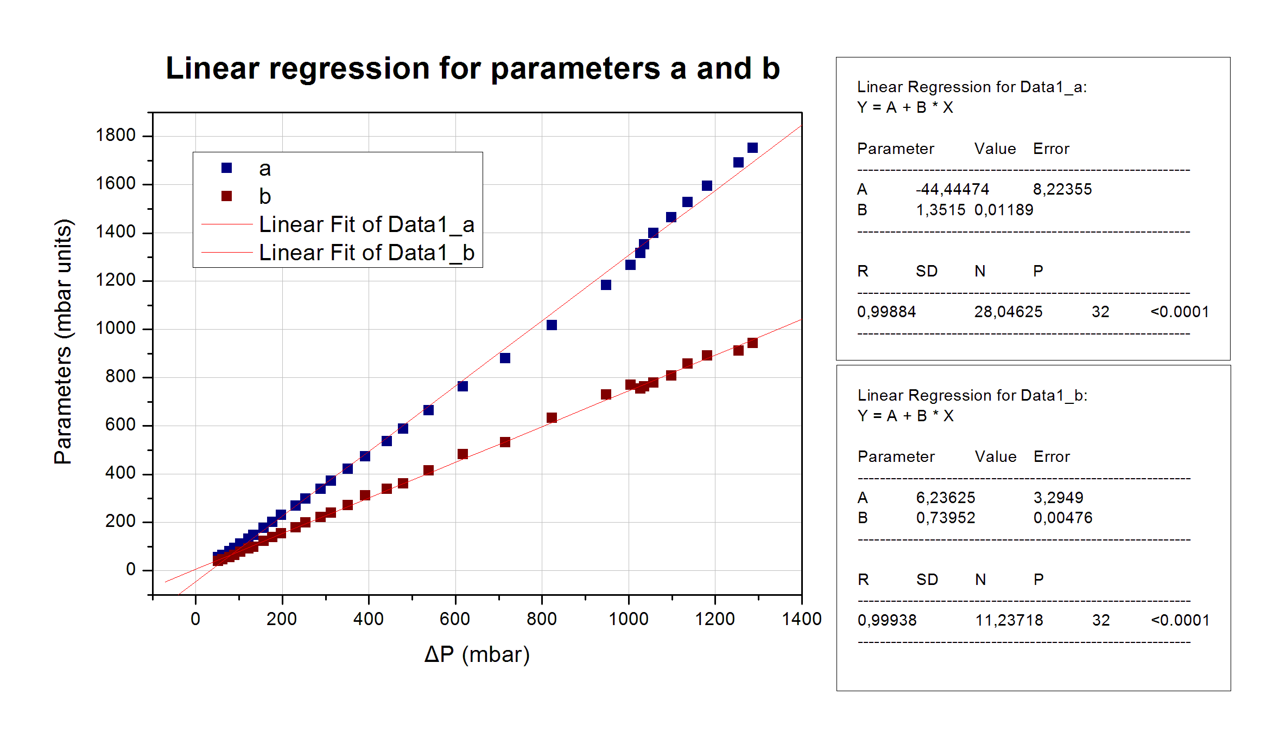

Graph 4: Parameters relation to ΔP

The parameters’ relation to ΔP can be safely regarded as linear in a first order approximation. Thus, both the maximum pressure that can be achieved by the pump and the parameter b are increased linearly with ΔP.

One more significant result can be derived from the pressure regression function. According to the experiment’s performance requirements, the pressure inside the sensorbox should be at least 800 mbar at the end of the pressurization stage. The function shows explicitly if the pump is capable of pressurizing the air over that target value, provided that it works for sufficiently long time. The only condition is:

The following plot shows the behavior of the parameter a over altitude. The requirement’s condition implies that the only acceptable region of this graph is the upper left. Hence, this requirement had been met up to 12.5 km or equivalently, for the first 45 minutes of the flight.

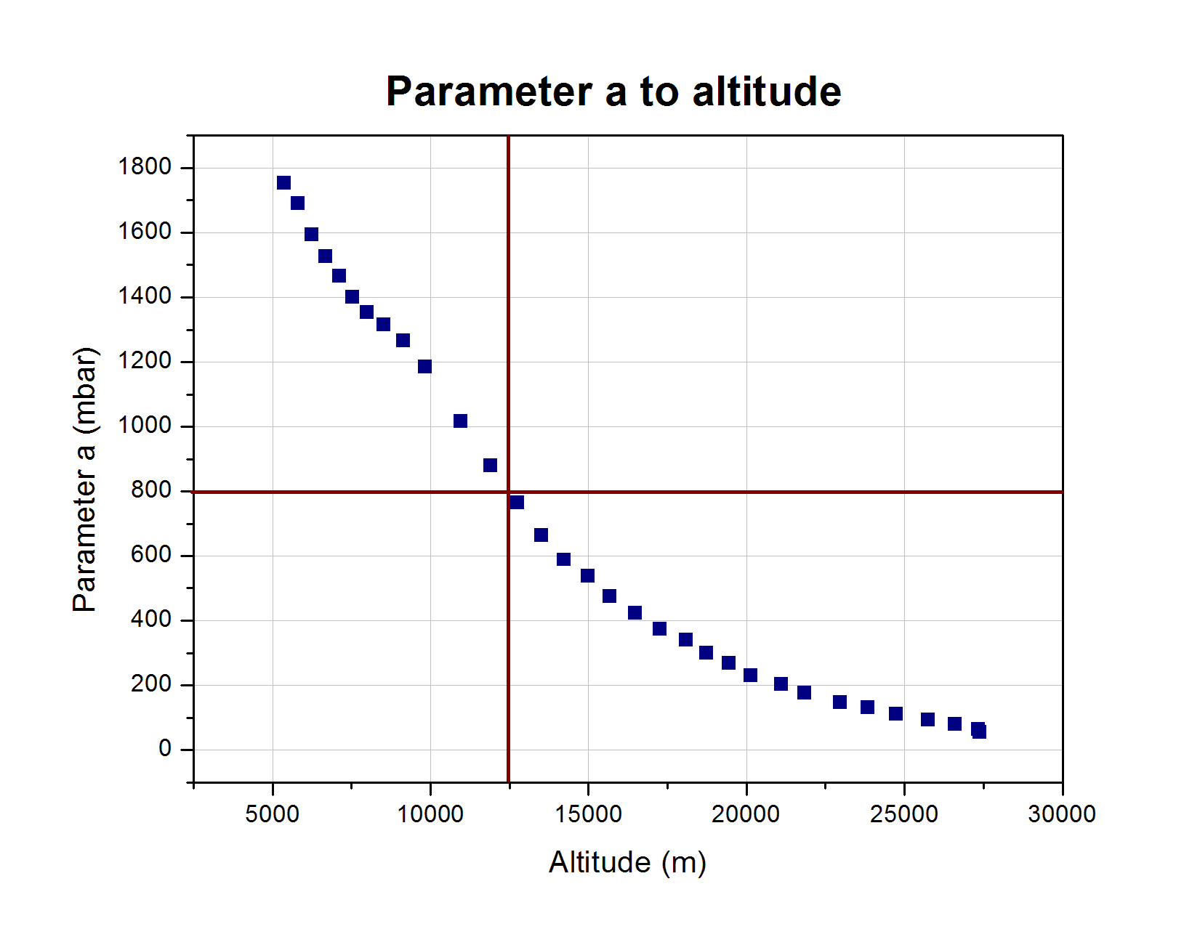

Graph 6: Performance requirement condition (acceptable region: upper left)

A more detailed examination of the pressure could provide more explicit information for their relation with the initial conditions. Yet, more details are not important for the experiment and will not be examined. What is important is that they depend on the initial conditions, regardless the closed form of the relation. Therefore, the regression function can be written as:

where this dependence is being implied with the symbol of the pressure generally.

# Conclusion

Returning to the formula:

and taking all the above into consideration, the flow-rate function can be written as:

or

or

It is explicit that the pump’s flow-rate function tends to zero. Hence, only if the initial conditions are favorable, the pump is able to pressurize the air sufficiently for the experiment’s needs. Considering the ambient conditions and the “**Performance requirement condition”** graph, this pump was not the correct choice for the whole flight of this experiment. An additional performance requirement is that the pump should provide a flow-rate of 3-8 L/min. It has been clear that the flow-rate always tends to zero, thus, in every cycle this performance requirement is not being met. Yet, taking the pump’s behavior into account, this requirement cannot characterize the efficiency of the whole experiment, since the pump could pressurize the air sufficiently up to 12.5 km.